KEYAZ CONSULTANCY
MIDTERM II EXAMINATION 2023
Age Group (4 – 5 years): MIDDLE CLASS
Learning Area 3: Health Habits

My name is ______________________________________________
School: _____________________________________________________
- Match the same fruits and draw.
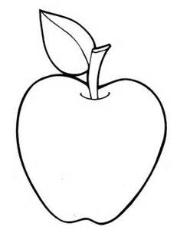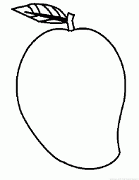
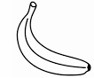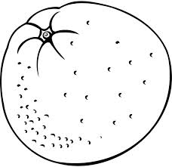

- Fill in the missing letter.
flower | 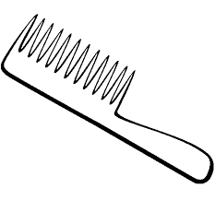 comb | water
flo____er | c___m___ | wat___r
  head | 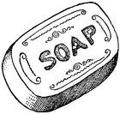  soap | tin
h__ad | s___ap | t___n

- Read and draw.
fish | cat | sun | ball
- Match body parts to senses.
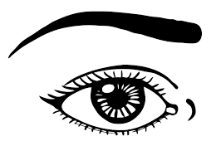
walking

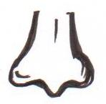
hearing

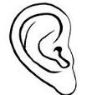

seeing

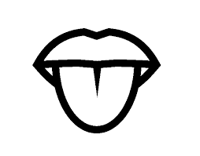

smelling

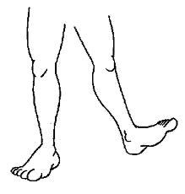
tasting
- Complete the sentences.
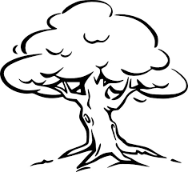
This is a tree.

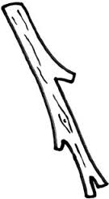
This is a ____________
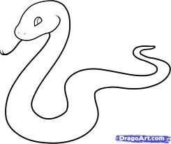

This is a ____________

This is a ____________

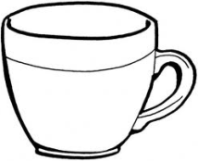
This is a ____________

(snake, cup, stick, pencil)

END

